Welcome to our first ever Wellbeing Newsletter! Every month I will be writing this newsletter and adding any useful websites, wellbeing news and challenges to focus on our mental health and wellbeing.

Since May is Mental Health Awareness month, here are some questions to ask your child if you are worried about their mental health. Remember the most important thing is to not judge and to listen carefully to their answers:
- Can you tell me more about what is happening? How are you feeling?
- Have you had feelings like this in the past?
- Sometimes you need to talk to an adult about your feelings. I'm here to listen. How can I help you feel better?
- Do you feel like you want to talk to someone else about your problem?
When talking about mental health problems with your child you should:
- Communicate in a straightforward manner
- Speak at a level that is appropriate to a child or adolescent's age and development level.
- Discuss the topic when your child feels safe and comfortable
- Watch for reactions during the discussion and slow down or back up if your child becomes confused or looks upset
- Listen openly and let your child tell you about their feelings and worries.


St Joseph’s Catholic Primary School
Wellbeing Newsletter 1
May 2024


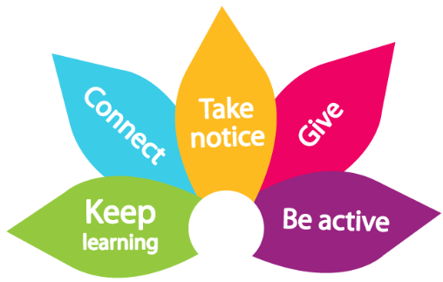
The 5 Ways to Wellbeing Challenge! BE ACTIVE!
This month’s challenge is to be active. Try one of these activities or some of your own. Keeping active makes us feel good and gives us a boost!
- dance to your favourite song * play a game in the playground * walk a dog
- hula hoop * walk or cycle to school * make up your own sport
- help in the garden * run a race with friends

Year 6 SATs Anxiety Workshop 1st May 2024- This was a workshop held by Georgia Kett, our link education mental health practitioner, from the Broxbourne Mental Health Support Team. Since the SATs are almost upon us and can be a stressful time for our Year 6 pupils, this was a much needed workshop, giving children the opportunity to talk about anxiety and stress surrounding the tests. Areas that were covered during the workshop were:
What is anxiety, what does anxiety feels like in the body, anxious thoughts and how to overcome these, sorting worries using a worry tree, how to solve worries about SATs, positive self-talk, understanding avoidance around revising for SATs, relaxation techniques (star breathing, lazy 8 breathing and hand breathing), distraction techniques (5,4,3,2,1 grounding and rainbow grounding) and progressive muscle relaxation.
Hopefully, all of these techniques will help our Year 6 pupils and we wish them the best of luck for the upcoming SATs. Remember Year 6, you are all amazing and so much more than the results you get!

