Featured Wellbeing Website. Anxiety UK.
In this section, we will look closer at one of the wellbeing websites that we recommend you visit if you feel you need a little extra support outside of school. This month’s website is: Anxiety UK https://www.anxietyuk.org.uk/. Anxiety UK is a national registered charity formed in 1970, by Katharine and Harold Fisher, for those affected by anxiety, stress and anxiety based depression. Anxiety UK helps to define anxiety and the different types of anxiety. They offer resources to help your child deal with anxiety and they even discuss the link between anxiety and nutrition. The website also has some great free resources including a ‘Breathing and Relaxation guide’ and ‘Panic Attack booklet’.
For other ‘wellbeing websites’ please visit our school webpage, click on the ‘Curriculum’ tab, select ‘Wellbeing’ then ‘Useful websites for Parents and Carers’.

St Joseph’s Catholic Primary School
Wellbeing Newsletter 2
June 2024

This month’s focus is on: Loneliness 
Did you know? In a 2019 survey, 16% of people in the UK said they didn't have anyone they felt they could rely on if they had a serious problem. The issue of loneliness is huge in our society, but what can we do to combat loneliness, especially when some people say they feel lonely even when they are with other people?
What can you try?
- Share feelings - We often feel lonely when we do not share feelings with people. Make it a priority to share your feelings with someone every day, as this will encourage them to do the same. This connection will ward off feelings of loneliness.
- Work out the ‘why?’ - Loneliness is not the same as being alone, so if you feel lonely, ask yourself whether it's due to lack of contact or lack of close contact. If it's the latter, consider who you could open up to and make an effort to make a closer connection.
- Connect with nature - If you are spending a lot of time alone, prioritise going for a walk in nature. It sounds counter-intuitive, but sometimes experiencing the sights and sounds of the natural world - even by ourselves - can make us feel part of something greater and therefore less lonely.

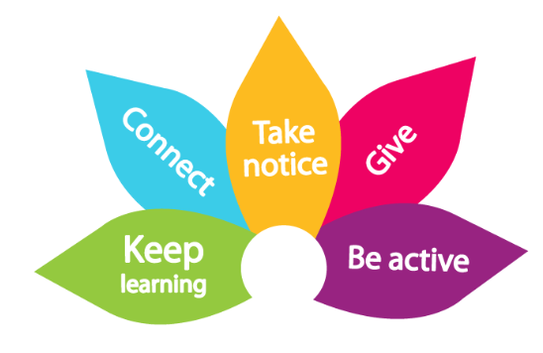


The 5 Ways to Wellbeing Challenge! TAKE NOTICE!
This month’s challenge is to take notice. Try one of these activities or some of your own. Take notice of the little things around you and pay attention to how you feel.
- Look at a cloud out of your window and watch how it moves and changes * play I Spy
- Paint or draw a portrait, pay attention to the features. * think about how you are feeling today
- Listen to the sounds of nature, like the wind or rain * notice how your friends and family are feeling today

