Y3 English Homework week 4 (7.5.26).
Page 1
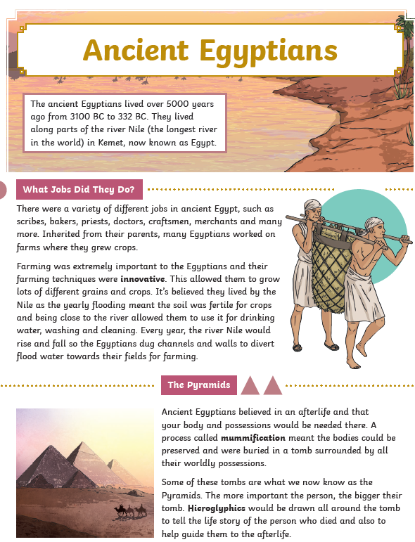

Y3 English Homework week 4 (7.5.26).
Page 2
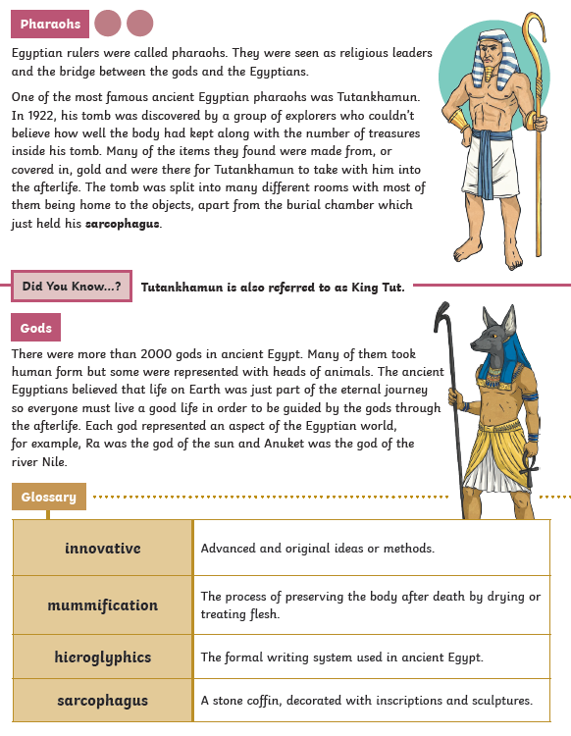

Y3 English Homework week 3 (7.5.26) Ancient Egyptians Comprehension.

Please just stick this answer sheet into your Homework book.

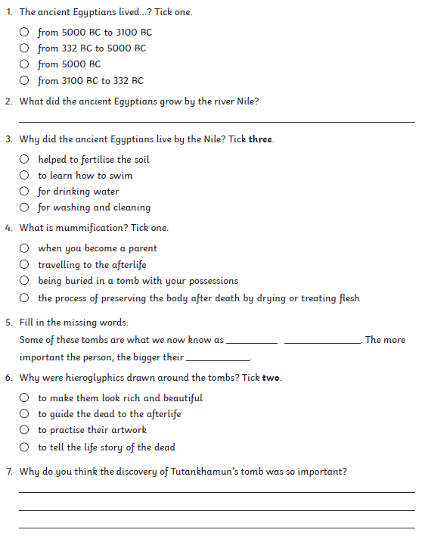

Y3 English Homework week 3 (7.5.26) Ancient Egyptians Comprehension.
ANSWERS



