Y3 Maths Homework week 5 (14.5.26)
Adding and subtracting fractions with the same denominator.
Please stick this sheet into your Homework Book.

Colour the correct number of sections in each circle and then colour more or less or erase some depending on the calculation. The denominator stays the same – you just have more or less sections depending on the calculation!
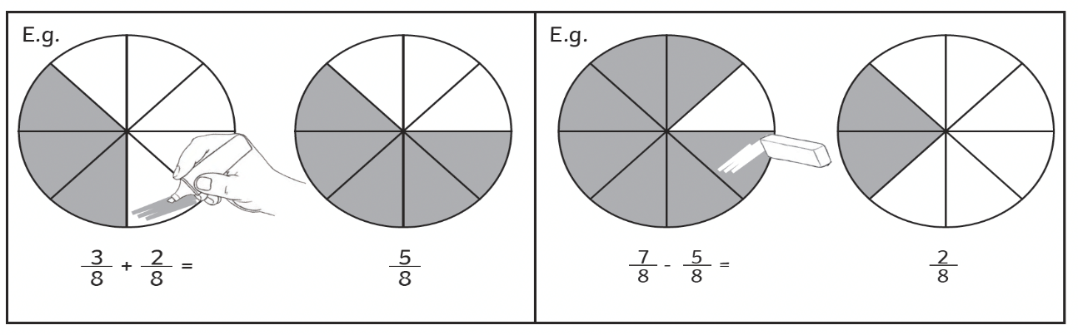
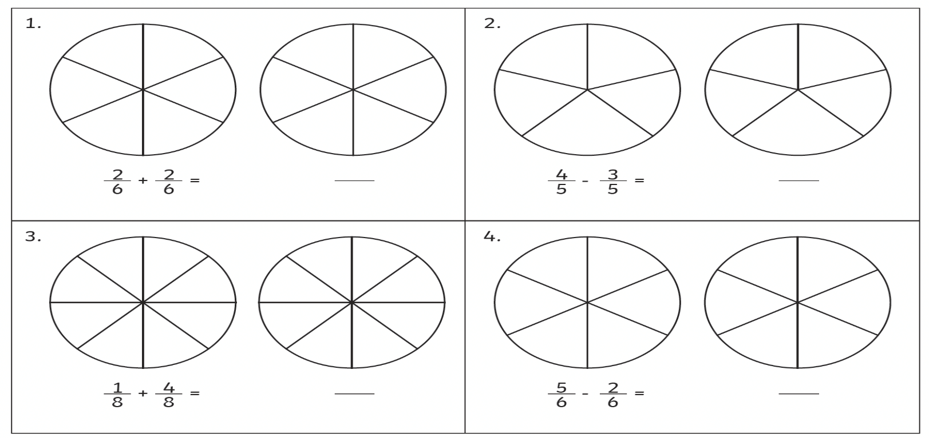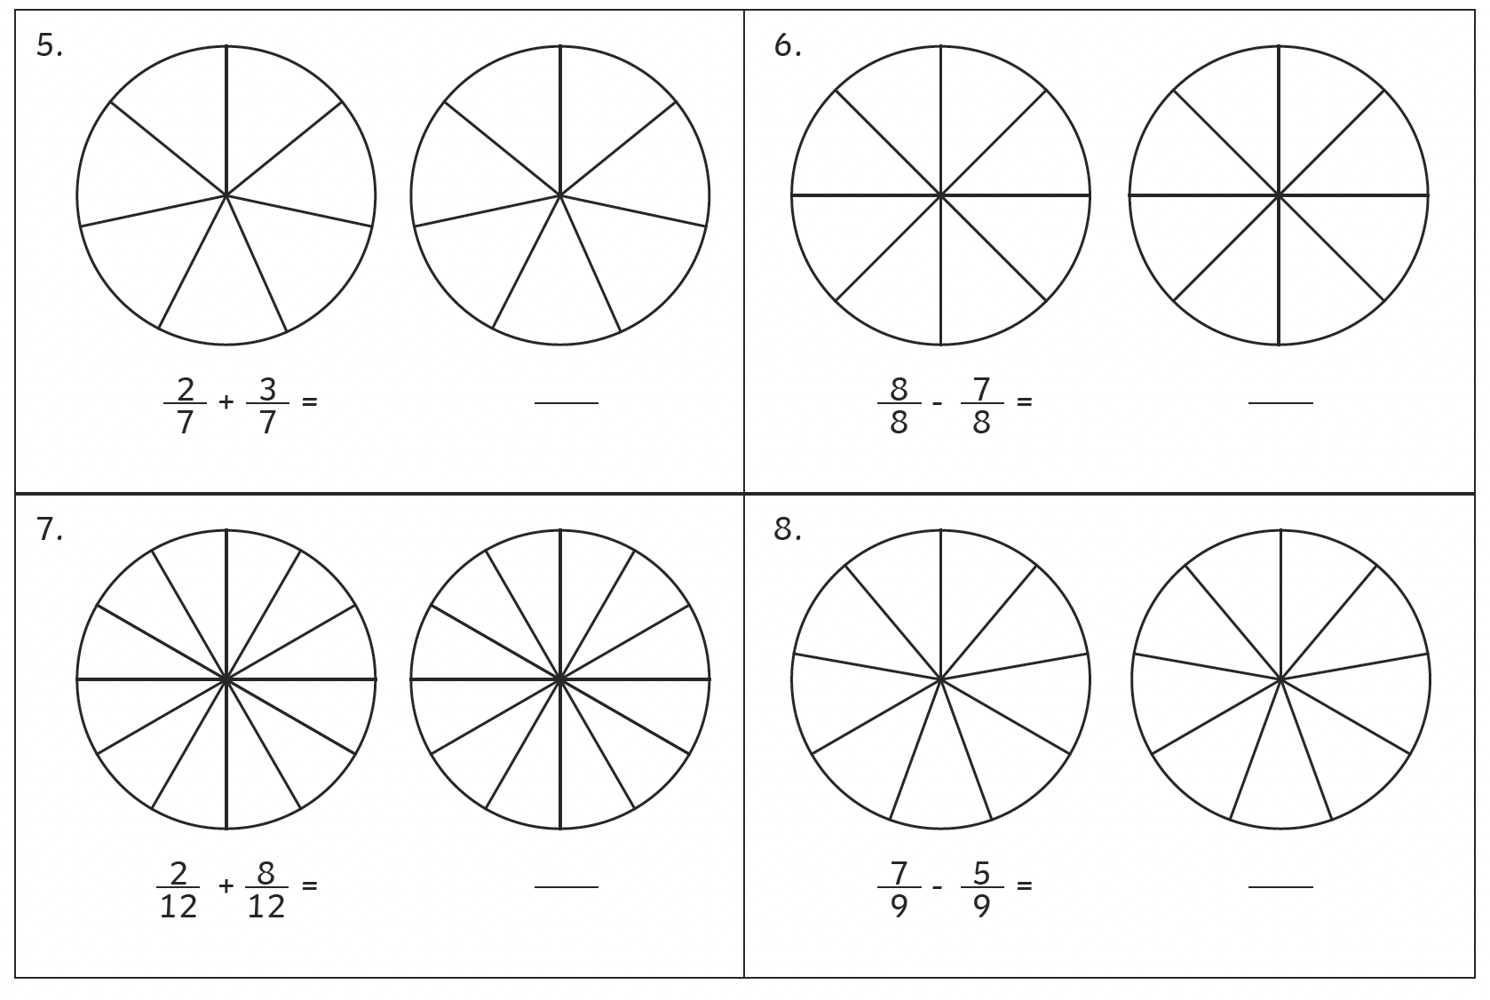

Y3 Maths Homework week 5 (14.5.26)
Adding and subtracting fractions with the same denominator.
ANSWER SHEET.



