Year 3 English Homework week 8 (11.6.26)

Please choose which challenge you’d like to do (or you can do both!) and complete the sentences using the word banks of conjunctions to help you.
Please only stick the completed answer sheet(s) into your homework book. Check and mark your work using the answer sheet which is on the Year 3 class page on the school website.

Challenge 1: 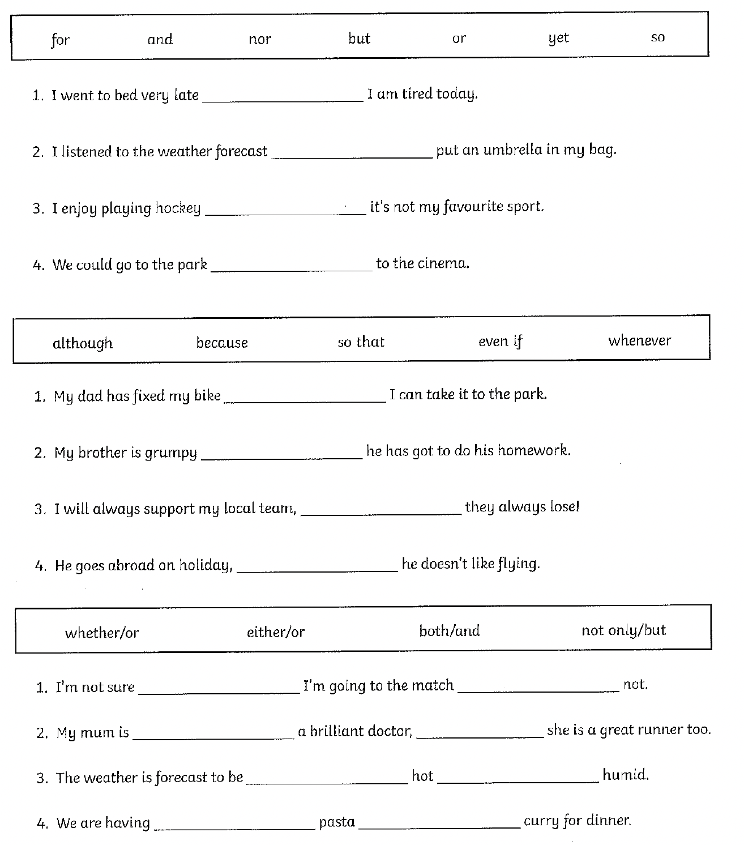

Year 3 English Homework week 8 (11.6.26)

Please choose which challenge you’d like to do (or you can do both!) and complete the sentences using the word banks of conjunctions to help you.
Please only stick the completed answer sheet(s) into your homework book. Check and mark your work using the answer sheet which is on the Year 3 class page on the school website.

Challenge 2: 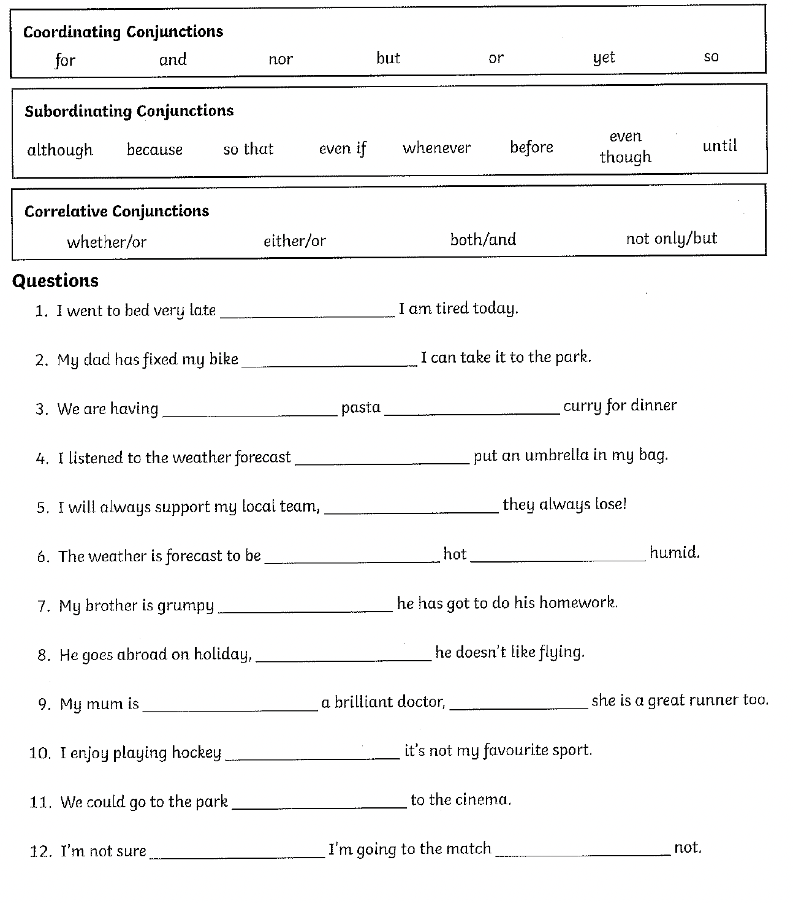
Year 3 English Homework week 8 (11.6.26)
Conjunctions: ANSWERS

Challenge 1:
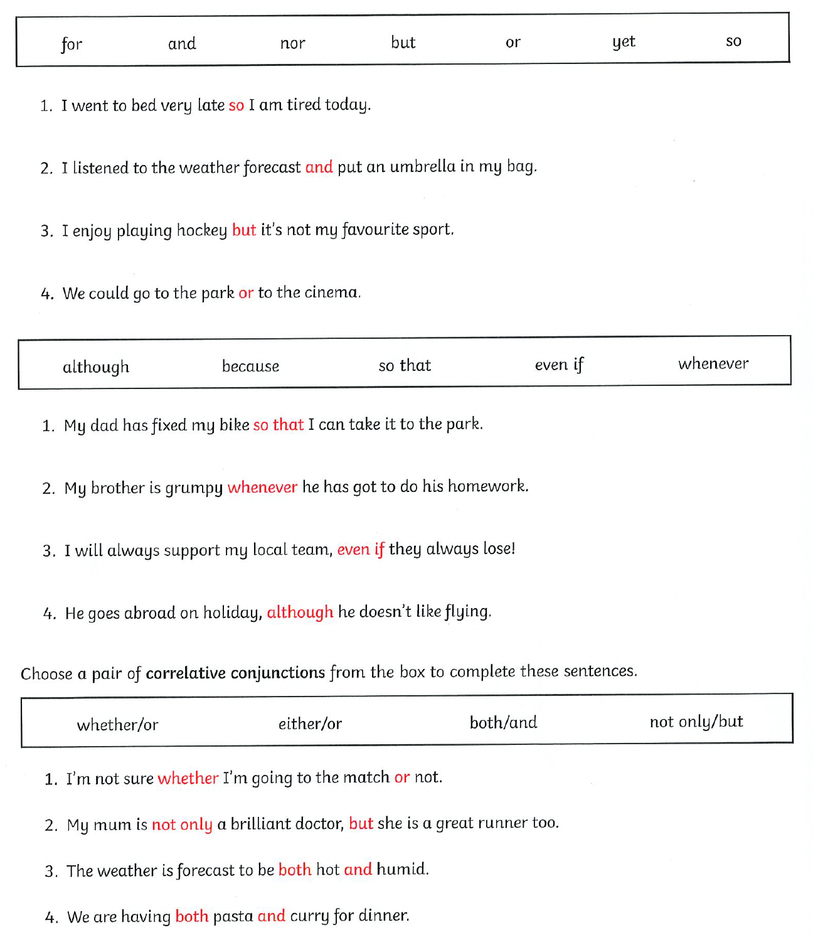

Year 3 English Homework week 8 (11.6.26)
Conjunctions: ANSWERS

Challenge 2:



