Y3 Maths Homework week 8 (11.6.26)

Calculating perimeters of regular 2D shapes.
You can choose which challenge you would like to do (you can do both if you want). Then
please mark your challenge(s) and then stick them into your Homework book.
Challenge 1:
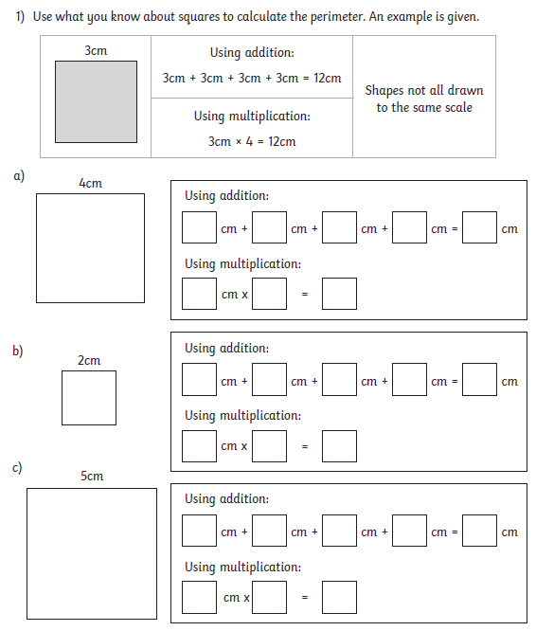

Y3 Maths Homework week 8 (11.6.26)

Calculating perimeters of regular 2D shapes.
You can choose which challenge you would like to do (you can do both if you want). Then
please mark your challenge(s) and then stick them into your Homework book.

Challenge 2:
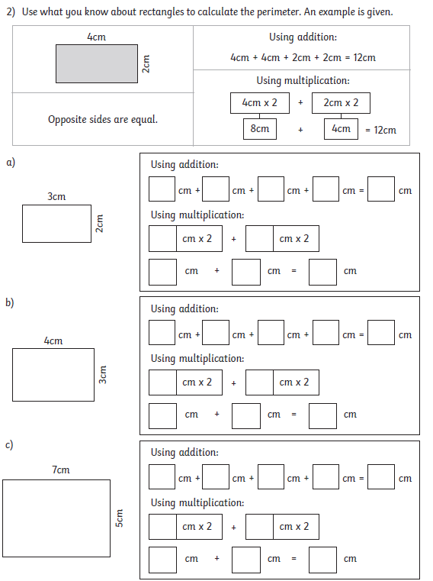

Y3 Maths Homework week 8 (11.6.26)
ANSWERS
Challenge 1:
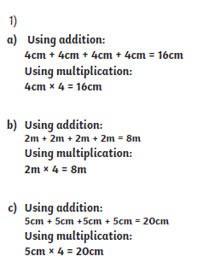

Challenge 2:


