Y3 English Homework week 10 (25.6.26)
Expanding noun phrases.

Hint: A preposition is a word that tells you where or when something is in relation to something else. A prepositional phrase adds more description or answers a question like where or when.

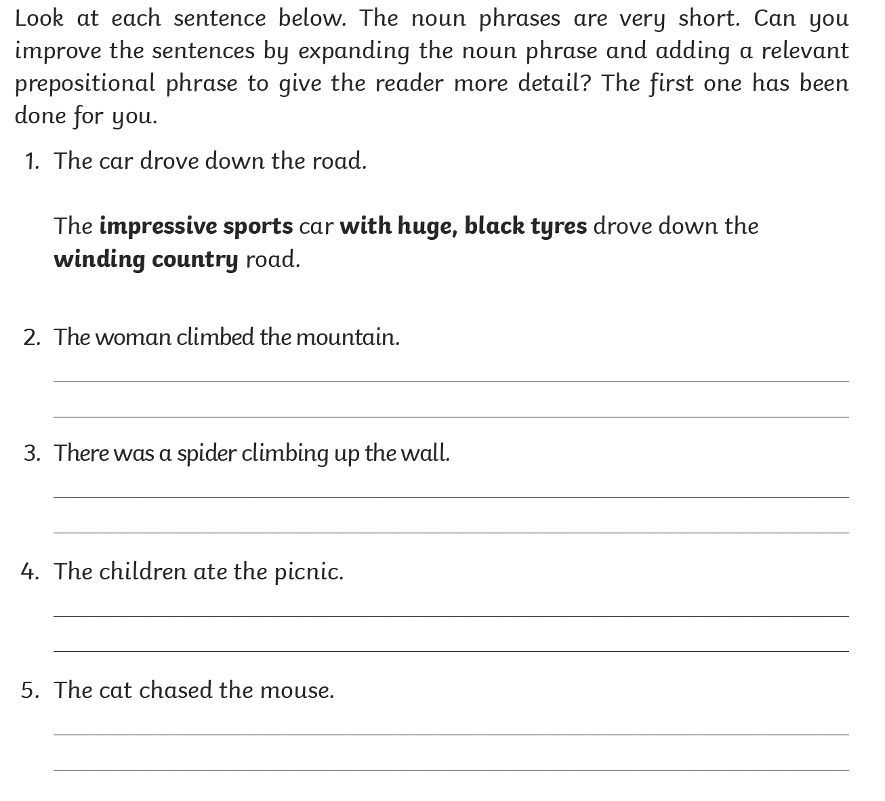

Make sure you stick this sheet into your Homework book.

