Y3 Maths Homework week 10 (25.6.26)
Tell the Time: Half and Quarter-hour. Please choose which Challenge you would like to do then stick it into your Homework book. Mark your Maths using the answer sheets on the school website.

Challenge 1:
1).
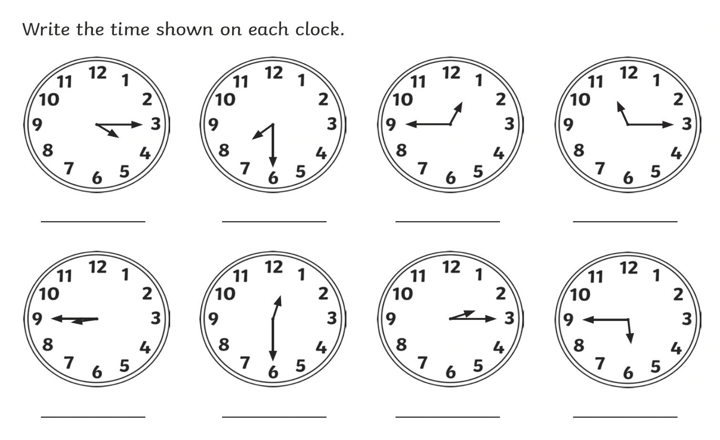
2).
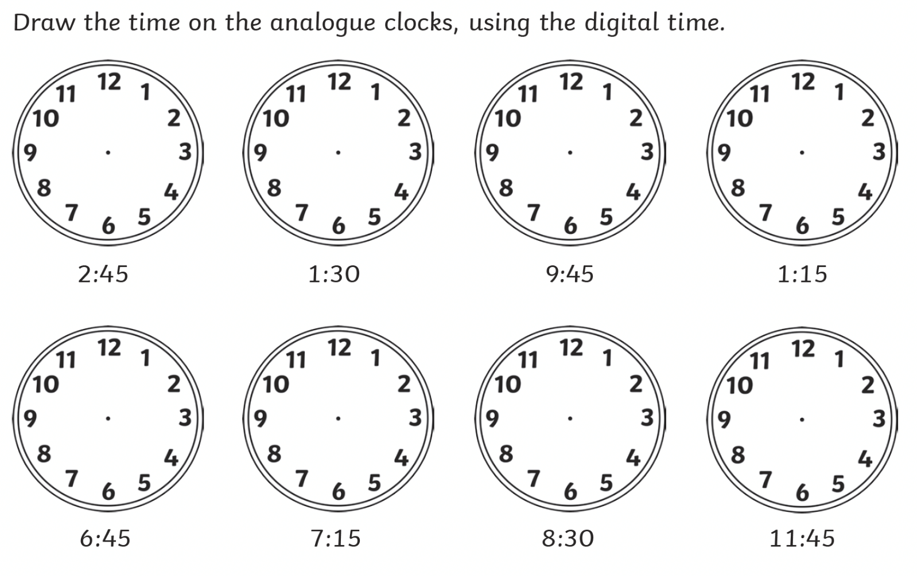

Y3 Maths Homework week 10 (25.6.26)
Tell the Time: Half and Quarter-hour.
Challenge 1: ANSWERS

1).
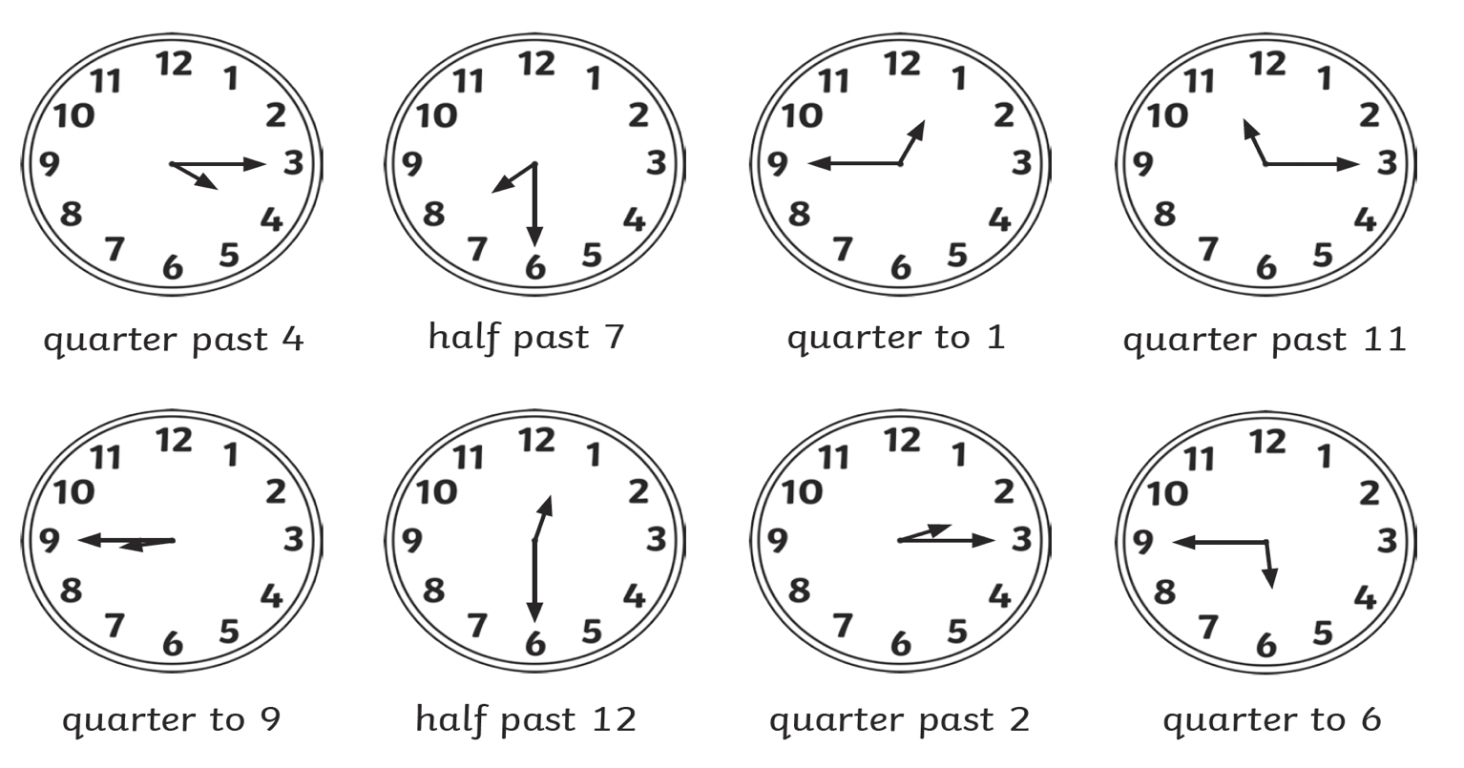
2).
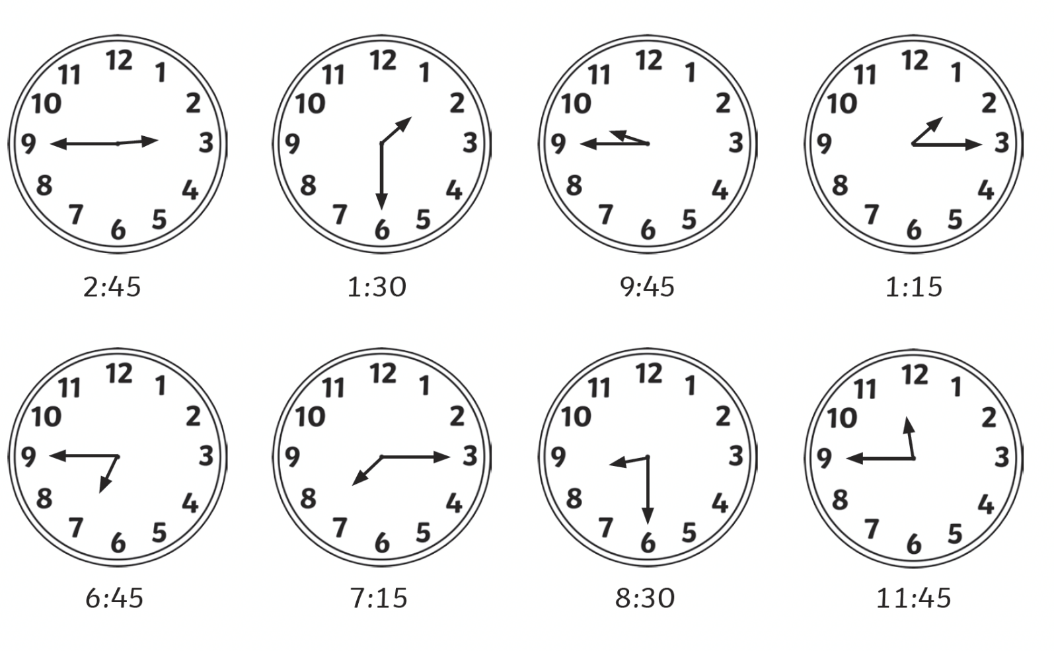

Y3 Maths Homework week 10 (25.6.26)
Tell the Time: Half and Quarter-hour. Please choose which Challenge you would like to do then stick it into your Homework book. Mark your Maths using the answer sheets on the school website.

Challenge 2:
1).

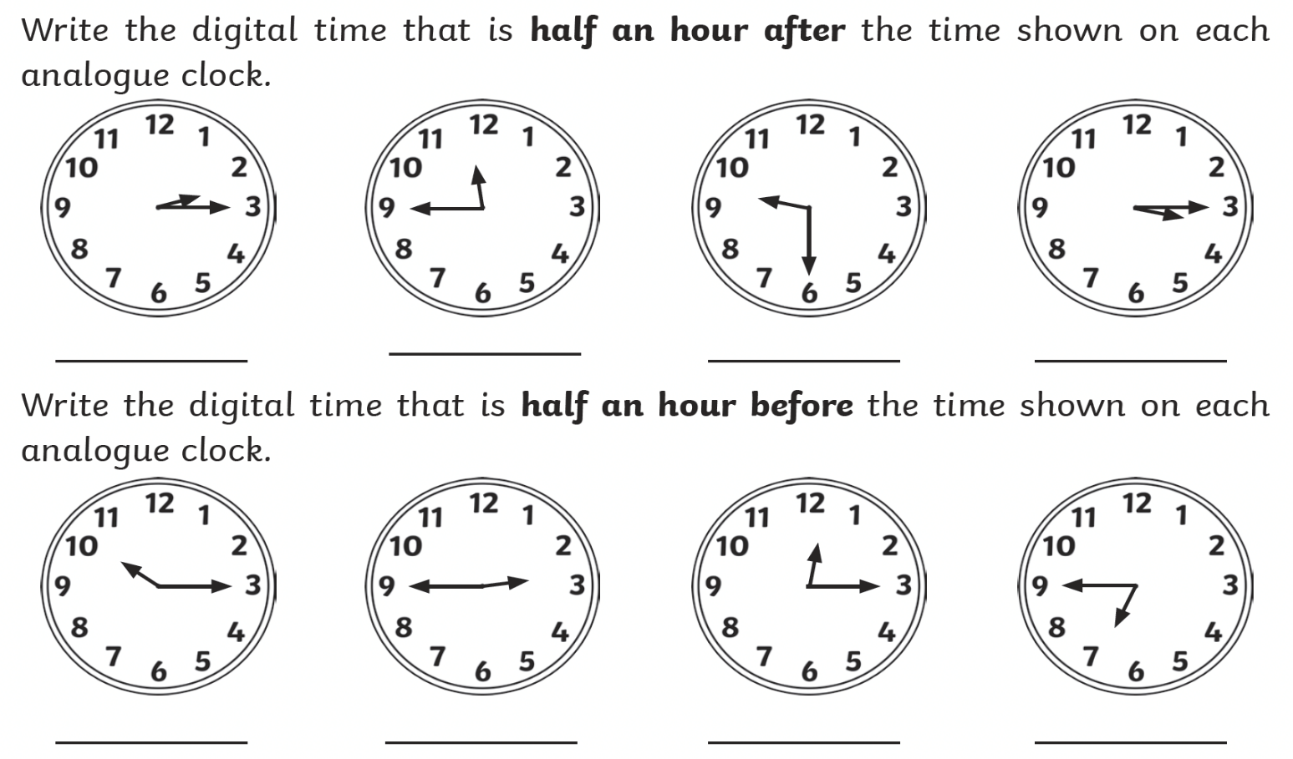

2).
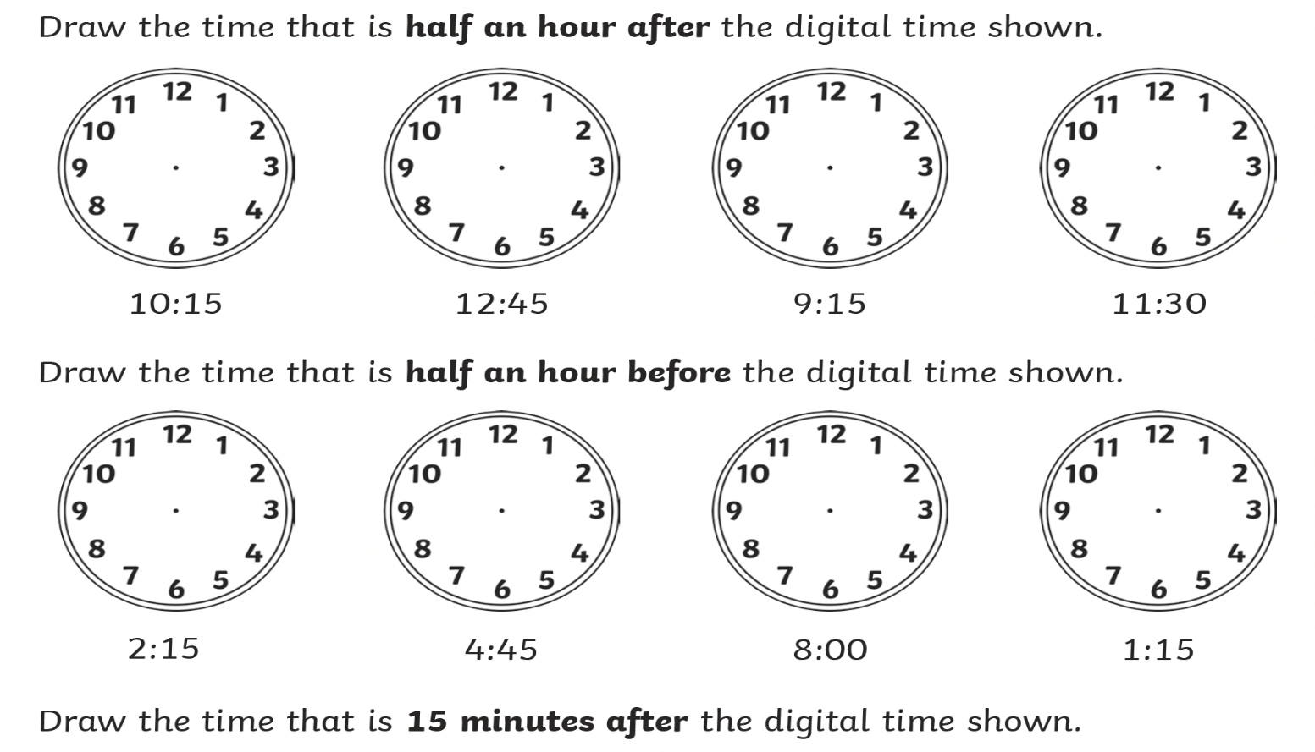

Y3 Maths Homework week 10 (25.6.26)
Tell the Time: Half and Quarter-hour.
Challenge 2: ANSWERS

1).
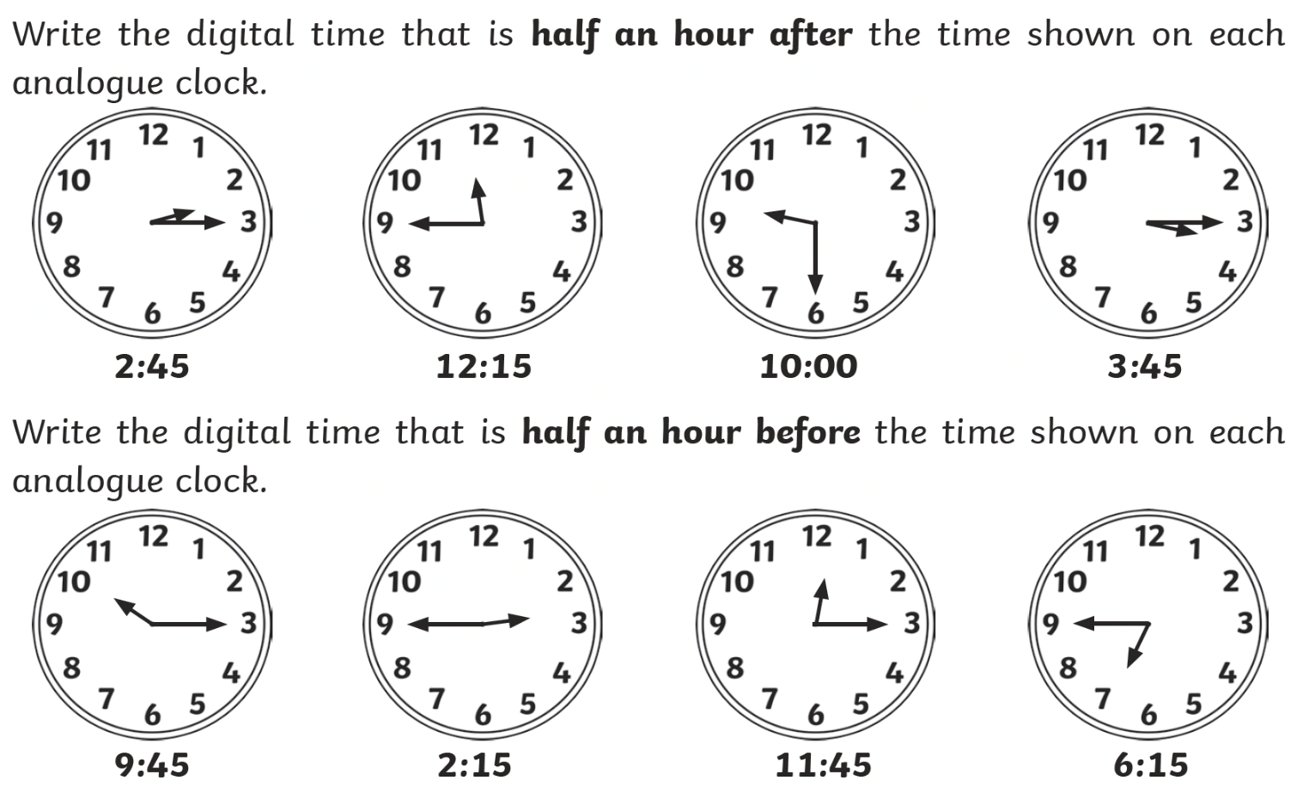

2).


