Homework
Year 2
Thursday 10th September 2026

Please return completed homework on Tuesday.

Reading
Please remember to read with your child daily and support them with understanding the text through comprehension, not just decoding the words.

Please make sure you sign your child’s reading record each time you read together and leave a comment. This helps us to know when your child is ready to have their book changed.

Spellings
Please see the attached spelling sheet to practise this week’s spelling words. These words are taken from our Year 1 and Year 2 Common Exception Word lists.
Please choose 4 words and write each one in a sentence. These spellings will be tested on Thursday.

English
Please complete the attached reading comprehension homework based on ‘Baby Animals’.

Maths
This week, we have been building numbers using Base 10 and looking at how many 10s and 1s are in different numbers.
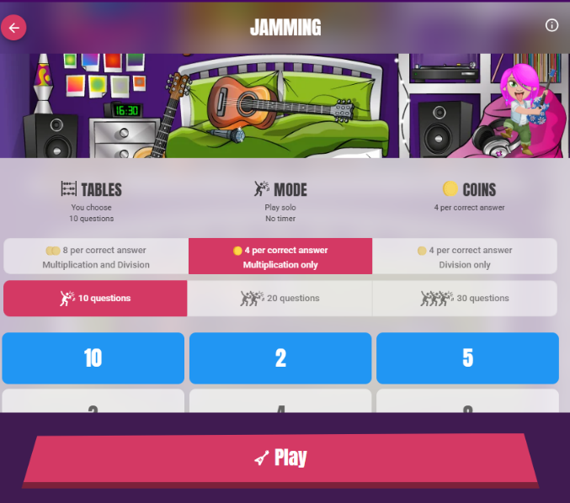
For example, there are 5 tens and 3 ones in the number 53. Please complete the attached worksheet.

Please also continue to practise your times tables on TimesTables Rock Stars.
Once logged in, please select Single Player, then Jamming, and
choose Multiplication only.

Please practise the 2, 5 and 10 times tables.

It should look like this:
Reminders
- PE days are Monday and Thursday.
- Reading books will be changed on Monday and Thursday.
- You child’s TT Rock Stars login is inside their reading record.

Thank you for your continued support. Have a lovely weekend!

Kind regards, Miss Perone and Mrs Nicolini

