Y3 Maths Homework (10.9.26)
Please choose to answer either Challenge 1 or 2 and stick the sheet into your Homework book. If you are not confident with 3-digit numbers then choose the 2-digit challenge.
Please mark your maths and make corrections using the answer sheet from the school website

Challenge 1: 2-digits

If you’ve chosen this challenge, then just stick this sheet in your Homework book.
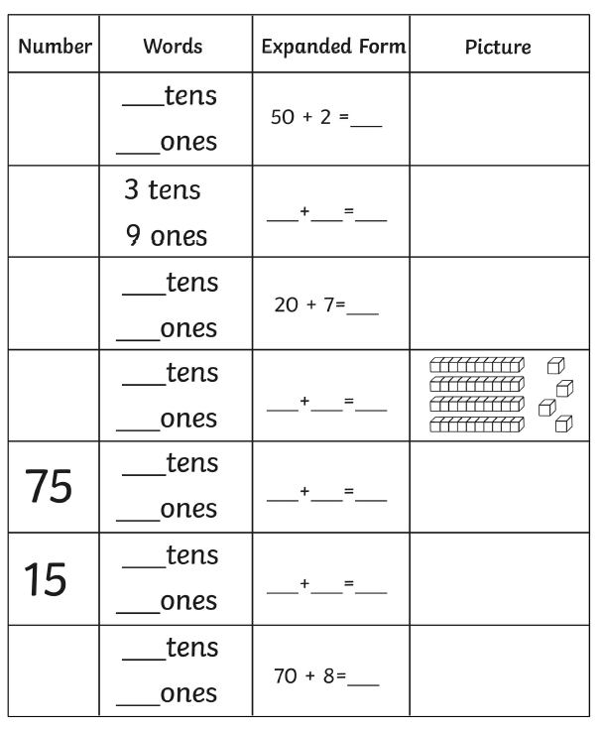

Now mark your work and make any corrections in green pen.

Y3 Maths Homework (10.9.26)
Challenge 2: 3-digits

If you’ve chosen this challenge, then just stick this sheet in your Homework book.

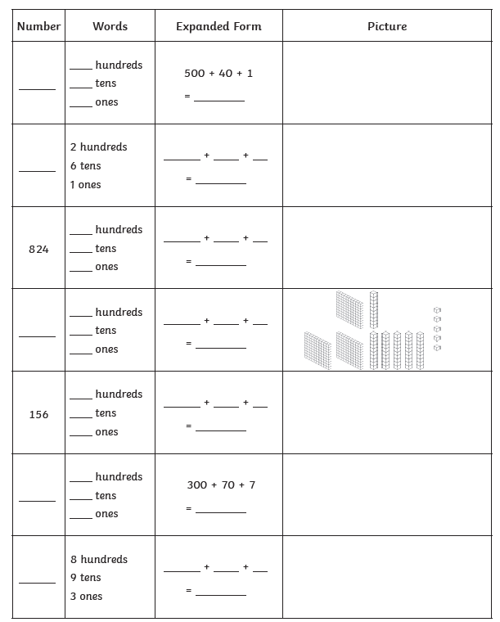

Now mark your work and make any corrections in green pen.

Y3 Maths Homework (10.9.26)
Challenge 1: 2-digits
ANSWERS
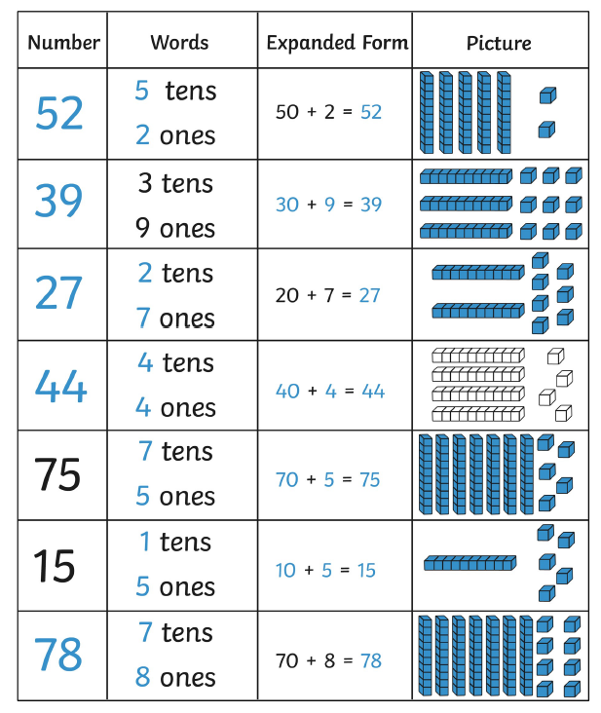

Y3 Maths Homework (10.9.26)
Challenge 2: 3-digits
ANSWERS


