Homework
Year 2
Thursday 17th September 2026

Please return completed homework on Tuesday.

Reading
Please remember to read with your child daily and support them with understanding the text through comprehension, not just decoding the words.

Please make sure you sign your child’s reading record each time you read together and leave a comment. This helps us to know when your child is ready to have their book changed.

Spellings
Please see the attached spelling sheet to practise this week’s spelling words.
Please choose 5 words and write each one in a sentence. These spellings will be tested on Thursday.

Maths
This week, there are two maths worksheets.
We have been looking at odd and even numbers and we have also been practising our 5 times tables.
Please complete the attached worksheets.

Please also continue to practise your times tables on TimesTables Rock Stars.
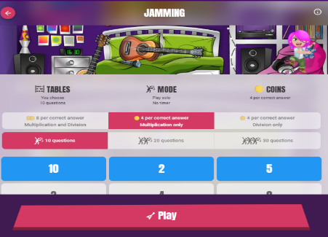
Once logged in, please select Single Player, then Jamming, and
choose Multiplication only.
Please practise the 2, 5 and 10 times tables.

Reminders
- PE days are Monday and Thursday.
- Please read daily with your and sign their reading record.
- Please ensure uniform is labelled clearly.

Thank you for your continued support. Have a lovely weekend!

Kind regards, Miss Perone and Mrs Nicolini

